5th Grade Math Lesson: Solar Energy Audit
Overview:
These lessons are group work based and will build on the students’ knowledge of solar energy. It will focus on interpreting data, using multiplication and unit conversion skills.
In Activity 1, students will learn how solar panels function and how they fit into a grid system. Activity 2 will have them identifying the variables of solar energy production by viewing graphs and maps. Students will then review how to calculate the cost of energy which they learned in the Cost of Electricity/Energy lesson. This will prepare them for Day 2, when as a class, they will calculate the energy production of the school solar panel system. Students will then discuss whether the school’s solar production can offset its energy usage.

Title: | School Solar Energy Audit
Timeframe: | 2 hrs (2 ~1 hour lessons)
Big Ideas and/or Essential Questions | How can we calculate the benefits of solar panels?  What is our own school’s solar energy production and how does it compare to our energy usage?
Vocabulary: | Electricity  Energy  Power  kW (kilowatt)  kWh (kilowatt hour) | Solar Energy  Solar grid  Net Metering  Audit
PA Standards: | Standard - CC.2.2.5.A.1 Interpret and evaluate numerical expressions using order of operations.  Standard - 3.4.5.E4 Describe how the use of symbols, measurements, and drawings promotes clear communication by providing a common language to express ideas.  Standard - 3.4.5.D3 Determine if the human use of a product or system creates positive or negative results.  Standard - CC.2.4.5.A.1 Solve problems using conversions within a given measurement system.  Standard - CC.2.4.5.A.2 Represent and interpret data using appropriate scale.
Students will be able to: | - Understand how a solar panel system turns sunlight into electricity.  - Calculate the cost of energy and the energy production of the school’s solar system using basic multiplication and unit conversion  - Determine the CO2 emissions that the school’s solar system avoids and understand the equivalency in terms of ICE cars (internal combustion engine) taken off the road.
Materials: | School solar panel data  Solar Data Handout  Math/Science notebooks  Projector/method of displaying images to the class  Grade level science textbook
Activity Procedures: | Day 1: ~1 hour  Activity 1: Review Solar Energy and Understand the Solar Grid (~15 min)  - Use the internet and/or textbook to write definitions for the vocabulary on the first half of the Solar Energy Vocab handout.  - Watch video how a solar panel works (video) and read the overview on Solar Energy and Solar Panels  - Have students match the definitions for the vocab from video on the rest of the Solar Energy Vocab handout.  - Utility Grid  - Net Metering  - Photons  - Solar Array  - Inverter  - Another optional video  Activity 2 (~15 min)  - Identify variables: In groups, make a list of variables that affect solar energy production (i.e. weather, location, orientation, cost) and share with the class. Then look at the maps and graphs and answer the questions. Use Solar Energy Variables handout.  Activity 3: Review kWh and cost calculation (from Calculating Energy Cost (~30 min)  - Go back to the Solar Energy Vocab list from Activity 1 and share definitions for kW and kWh.  - Is a kWh a unit of energy or power?  - kWh measures the amount of energy that an appliance or device uses to run for one hour.  - Write a simple problem up on the board for students to solve in their notebooks: if the cost of energy is 10 cents per kWh, then how much does it cost to run a 0.2 kW microwave for 2 hours throughout the day?  - This would use 0.4 kWh.  - 0.4 kWh * 0.10c to get the cost.  - Start on the Homework Problems 1 and 2 from Solar Production and Usage Worksheet. This will get the students ready for the calculations needed for the solar energy audit on Day 2.  Day 2: ~ 1 hour  Activity 4: Class Discussion (~5 min)  - Have everyone in the class write on the board a way they saw energy being used at the school that week.  Activity 5: Solar Audit (~40 min)  - Display school solar panel data and have students identify important variables and numbers by filling in the Solar Data Handout chart in groups. (this chart asks for the energy production each month.  - Come together as a class to agree on the identified data by filling in the chart on the whiteboard. (Have each group come up to add a different number).  - Create a histogram of the kWh production each month on the board.  - (Histogram Lesson Plan below)  - Using the histogram, observe how much energy was produced each month. Make observations on the variability and what factors could play into it: weather conditions.  - Finally, using basic multiplication:  - Calculate how much energy was produced in 1 year.  - Using the rates of electricity, calculate the total money saved in 1 year by the electricity generated by the school’s solar panels.  Activity 6: Our energy usage  - Have students brainstorm all the ways in which energy is used in the school and rank them from most energy usage to least. If the teacher has access to the school’s energy usage data, then display that on the board or screen in a simple list or chart.  - Breakdown of an average schools’ energy usage (link):  - Lighting: 26%  - Cooling: 26%  - Office Equipment: 20%  - Other: 10%  - Ventilation: 5%  - Refrigeration: 4%  - Cooking: 1%  - Water Heating: 1%  - Add pie chart exercise  - As a class: using the school data (or state averages), calculate the energy usage in 1 year of the school. Then calculate the cost of that energy (using school data or state average).  - Finally, put together this final cost number and the calculation from Activity 3 on electricity generation to find a difference (using simple addition).  - Closing question: Is our school's energy production from the solar panels enough to make up for our energy usage? If not, what are ways we can conserve energy in the school?
Homework: | After Day 1, students will complete the Solar Production and Usage worksheet to prepare them for Day 2. The worksheet consists of simple problems about a solar energy system. It asks the students to calculate energy production (energy*time), energy usage (energy*time) and cost (cost per kWh*kWh), then calculate the difference to determine if the energy production can offset the energy usage.
Extension | ICE car activity. What is an ICE car? In PA, if a solar system generates 40 megawatt hours a year, how many ICE cars would you need to take off the road to get the equivalent reduction in CO2?
Assessment: | Calculating solar production.  Calculating energy usage.  Calculating cost.  Interpret data.

Name:_________________ Date:________

Solar Energy Vocab

Instructions: Use your textbooks and/or the internet to write brief definitions for the following words relating to Energy and Solar Energy. Work in your table groups.

Energy:

Electricity:
Power:

kW or Kilowatt:

kWh or Kilowatt Hour

Solar Energy

We will now watch a video explaining how solar panels work!

After the video is done playing, use this new knowledge to connect the following words to their definitions:

Draw lines from the words to their definitions.

Vocab from Video

Utility/Electric Grid
A particle of light which contains electromagnetic energy.
Solar Array
The grouping of solar panels.
Inverter
A connected network that generates and distributes electricity across a large area.
A system in which solar panels are connected to the wider electric grid and surplus power is transferred to the grid in exchange for credit.
Photons
Net Metering
A device that converts direct current (DC) electricity into alternating current (AC) electricity, which the electrical grid uses

Solar Energy and Solar Panels

Instructions: Read the following overview of solar energy and photovoltaic technology then write one question you have at the bottom of the page.

Solar energy is the most abundant type of energy available to us on Earth. Solar energy comes from sunlight (or solar radiation) which contains electromagnetic energy. One particle of light is a photon. Solar radiation can be captured and turned into both electricity and heat using various technologies. The Earth receives sunlight every single day, although the amount of radiation depends on location, time of day, weather, and season. In one hour, enough solar energy reaches the earth to meet a year's worth of our nation's energy needs.

But how do we harness this abundant amount of solar energy and convert it into electricity? Using photovoltaic (PV) technology, we can convert sunlight into electrical energy. A single PV device is a cell, which produces around 1 to 2 watts of power. Solar cells are usually made of silicon (the substance that makes up sand) or other semiconductor materials. These cells are then sandwiched between protective materials like glass or plastic. A connected group of solar cells is called a panel and a connected group of panels is called an array. These arrays are then connected to the electrical grid.
Solar panels can be put anywhere, although they are usually on rooftops or open fields where they can get the most sunlight. A solar panel works when photons from the sun strike the solar cell and knock the electrons free from the material’s atoms. The movement of the electrons generates an electric current. Metal conductive plates on the sides of the cell collect the moving electrons and transfer them to wires. At this point, electricity flows through a solar inverter, which converts the direct current (DC) electricity into alternating current (AC) electricity which can be fed into the commercial electrical grid.

Question:

Solar Cell System Diagram
The following image shows the elements of a solar cell system installed in someone’s home. Note how the orange wires connect the house’s system to the wider utility grid.

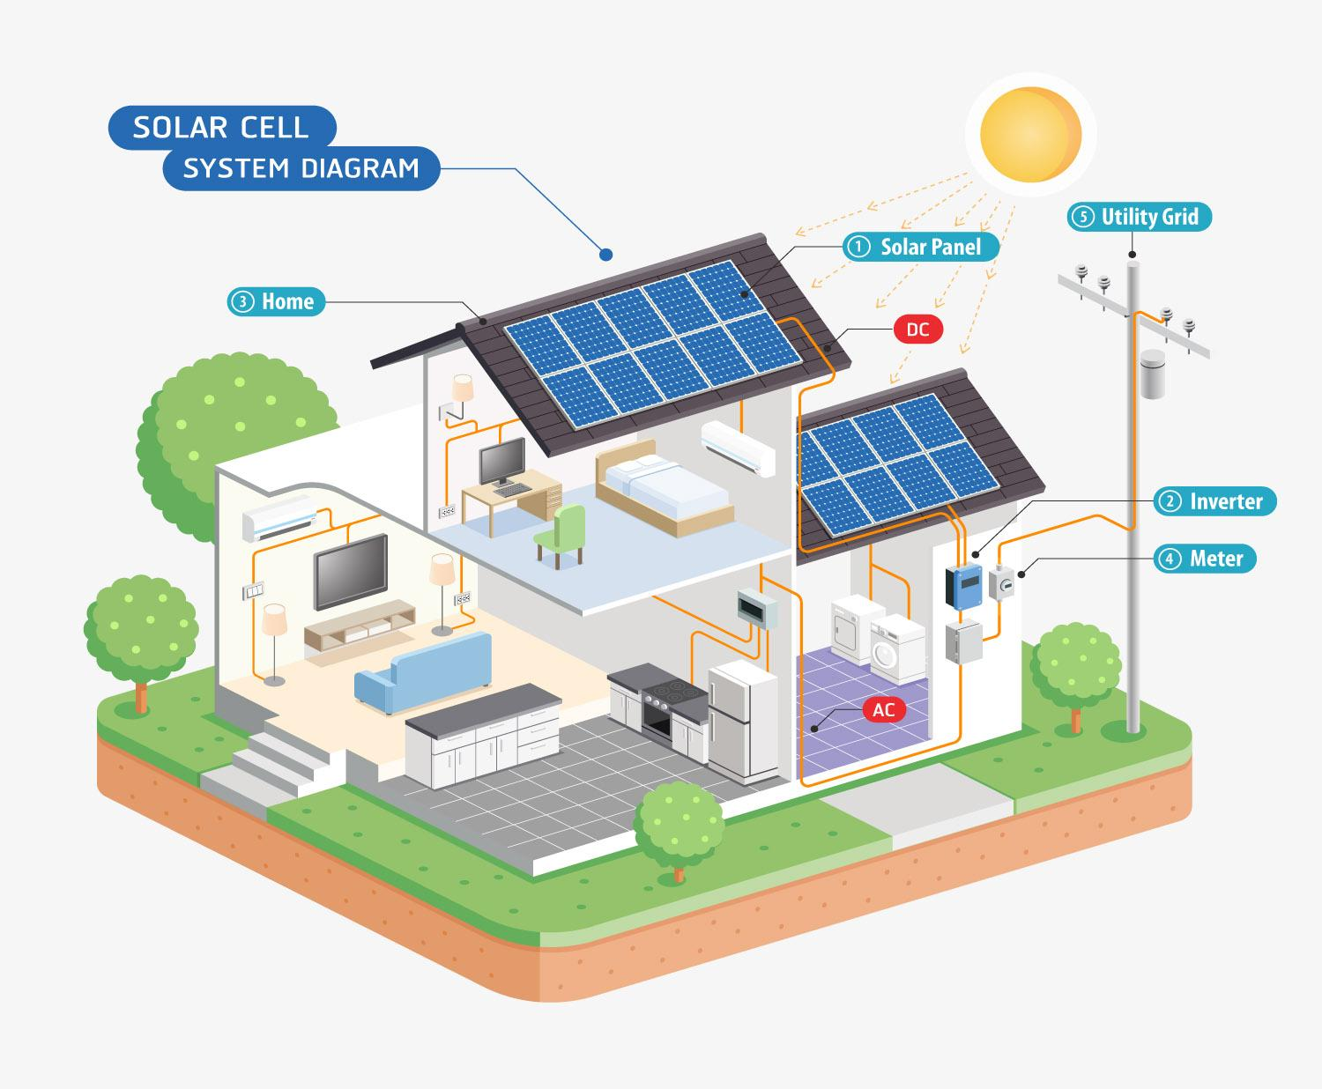
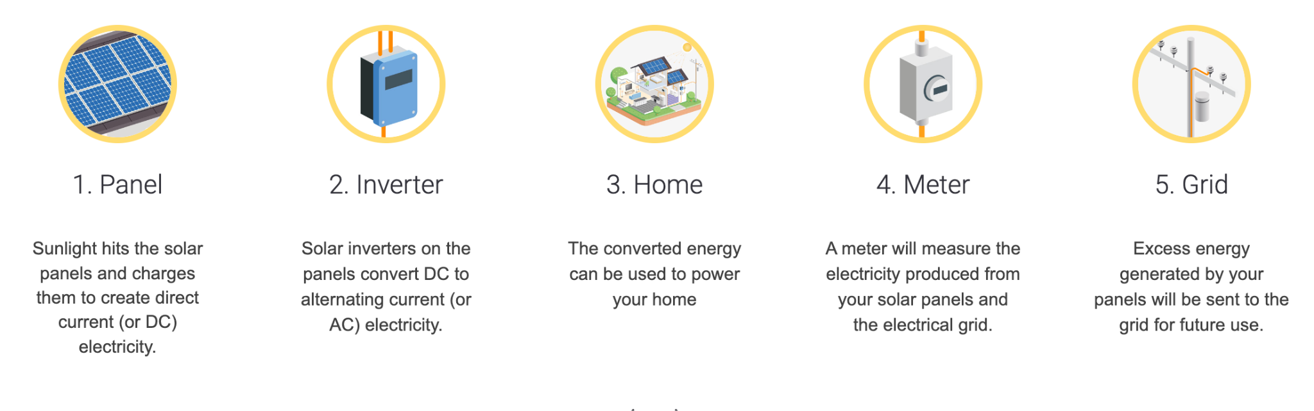
Images from solarisesolar.com

Solar Energy Variables
Instructions: In your table groups, brainstorm at least 4 variables that could affect solar energy production. What could cause solar cells to produce less electricity? What could help them produce more?

Variables: | How it would affect energy production:

Next: Answer the following questions after discussing with your group. You can use the graphs and maps on the following pages to help you ideate.

Will you get more energy production from your solar power system in the winter or in the summer?

Will you get more energy production on a cloudy day or a sunny day?

What about on the north pole versus on the equator?

Take a look at the following maps and graphs and answer the corresponding questions:
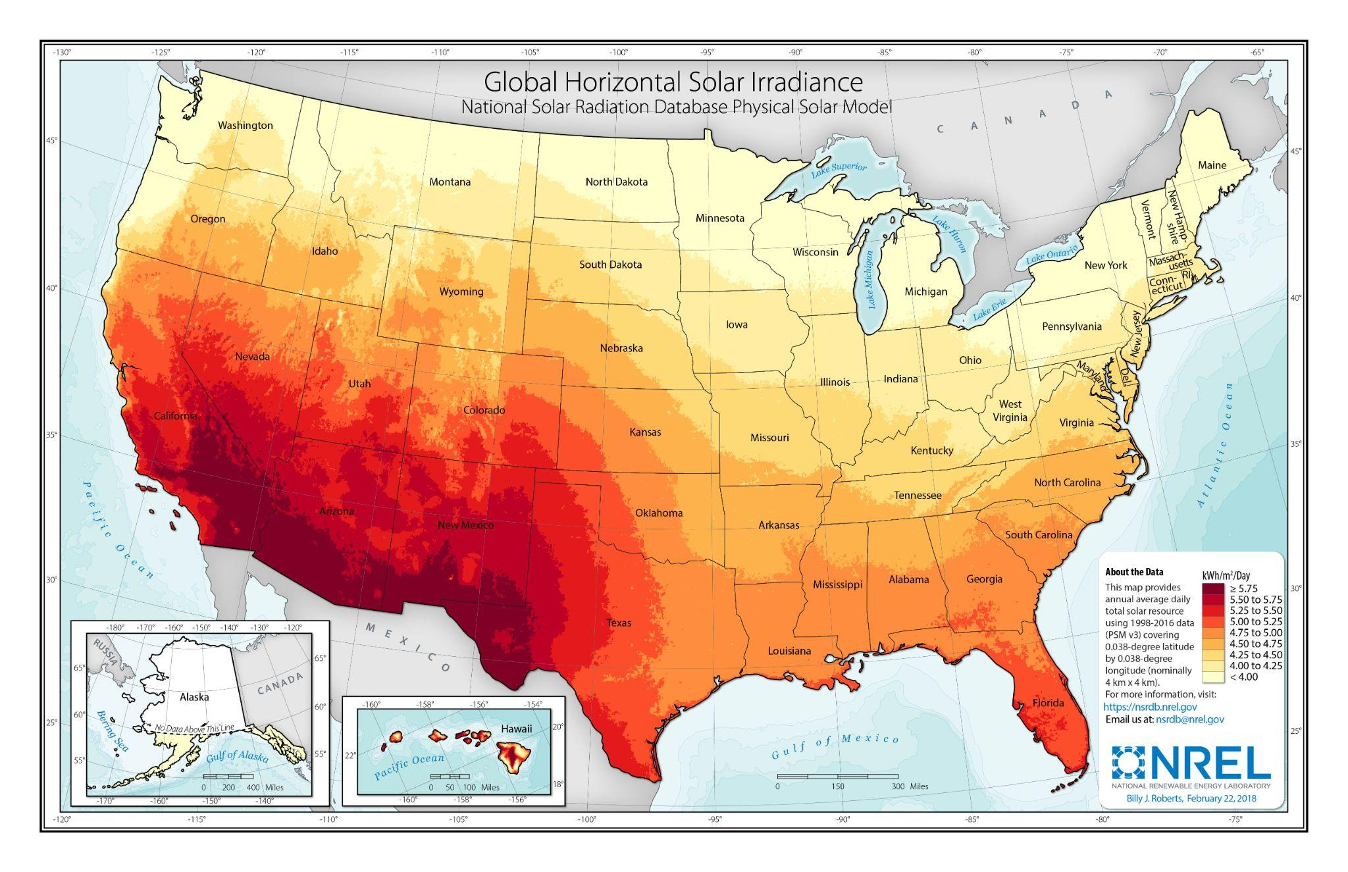
This map shows the amount of sunlight the US gets per day.
(Solar irradiance means the rate at which solar energy falls onto a surface. In this case it is measured as kWh/m²/Day.)

As the colors on the map get darker, does that mean the those areas get more sunlight or less sunlight?

What would be the best location to set up a solar power system in order to harness the most amount of solar energy?

Graphs from EIA
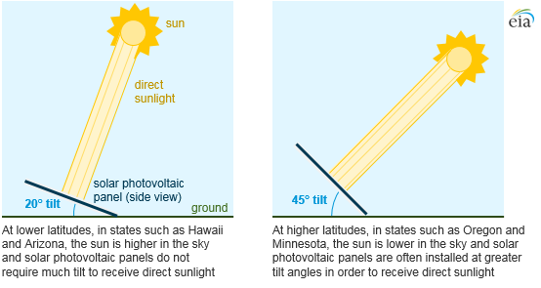
Figure 2

As you can see in Figure 2, the best tilt for a solar panel corresponds with how low the sun is in the sky. Where the sun is in the sky depends on where you are in the world. Closer to the equator, the sun is more directly above the ground, but closer to the poles, the sun is closer to the horizon.

If you are on the North Pole, will the sun be low in the sky or high in the sky?

If you are on the equator, will the sun be low in the sky or high in the sky?

If you live in Ecuador, which is on the equator, would you want your solar panels to have a tilt or be flat?

The ideal tilt for a solar panel system usually corresponds with the latitude of where you are in the world. We are currently in Pennsylvania (at a latitude of around 40°N), where the ideal tilt for a solar panel system is between 30° to 45°.

Homework: Solar Production and Usage Worksheet
Unit Conversion Review:

Incorporate images and graphs in this worksheet.

Convert

Complete Problems 1 & 2 in class

A solar panel generates

Look at the set of data showing

Solar Data Handout
Now we will take a look at our own school’s solar panels! Using the monitoring system, we can see the output of our solar power system (how much electricity we have produced).

In your table groups take a look at the data and fill in the table below.

Month | kWh produced
January
February
March
April
May
June
July
August
September
October
November
December
Total over the year

Using the above chart that you have just filled in, sketch a histogram on the next page. Work in your table groups.

Jan
Feb
Mar
Apr
May
Jun
Jul
Aug
Sep
Oct
Nov
Dec
Month
kWh

Answer the following questions after creating a histogram.

In what month did our school produce the most energy? Why might there have been more solar production this month?

In what month did our school produce the least energy? Why might this be?

Histograms and Other Simple Graphs as they relate to Energy
Overview:

Title: | Histograms and other Graphs on Energy
Timeframe: | 45 min
Big Ideas and/or Essential Questions
Vocabulary:
PA Standards:
Students will be able to:
Materials:
Activity Procedures:
Homework:
Extension
Assessment:

c. variability in production by weather conditions, e.g. rain, cloud cover, etc.
d. determine how much money the school is saving with the solar system
e. determine how many tons of CO2 emissions the solar system avoids.
f. What is the equivalency in terms of ICE cars taken off the road?
  - ICE (internal combustion car) vs EV (electric vehicle)

Brainstorm:
- Learn about the components of a solar power system
  - 3 key components:
    - Solar panels
    - Inverter
    - Racking
    - Method to store energy (if you are connected to the grid, the electricity goes right into it, but off grid means you need batteries and a charge controller)
- What makes an energy source renewable? Discuss different sources of energy and why they may or may not be renewable.
- Use school solar panel data to fill in a worksheet with data points for kWh produced per month
- Identify variables
  - Make a list of variables that affect solar energy production (i.e. weather, location, orientation, cost)
  - Why might electricity cost more in some areas?
- Identify the effects that weather have on solar energy production
  - Look at maps of the US and of Pennsylvania of sunshine/shade by location
- Discuss the space needed for solar panels. What are smart ways to incorporate solar panels into spaces?
  - Show images: solar panels on parking lots (provide shade as well)
  - Solar panels on roofs

- Inequalities: Make observations about the collected data. Compare production by month.
- Converting between measurement systems
  - Use conversions to accurately compare different energy systems: CO2 emissions versus solar energy
  - Visualize energy unit conversions
- Activity: in groups, brainstorm as many ways to save energy in the school, then come back together and share.
- Understand how cost plays into solar energy. Could your energy bill go to $0 if you produce enough electricity from your solar panels?
- ICE car activity:
- Photovoltaic technology: https://www.seia.org/research-resources/solar-photovoltaic-technology

Definitions
Solar energy: Power gained from the energy of the Sun’s rays, which can be transferred into electricity.

Standards:
Summarized:
- Multiply/divide fractions
- Rounding as it pertains to whole numbers and decimals
- PEMDAs, order of operations
- Using conversions within a given measurement system

Standard - CC.2.1.5.C.2
Apply and extend previous understandings of multiplication and division to multiply and divide fractions.
Standard - CC.2.1.5.B.1
Apply place value to show an understanding of operations and rounding as they pertain to whole numbers and decimals.
Standard - CC.2.2.5.A.1
Interpret and evaluate numerical expressions using order of operations.
Standard - CC.2.4.5.A.1
Solve problems using conversions within a given measurement system.
Standard - CC.2.4.5.A.2
Represent and interpret data using appropriate scale.
Standard - CC.2.4.5.A.4
Solve problems involving computation of fractions using information provided in a line plot.
Standard - CC.2.3.5.A.1
Graph points in the first quadrant on the coordinate plane and interpret these points when solving real world and mathematical problems.
Standard - 3.2.5.B2
Examine how energy can be transferred from one form to another.
Standard - 3.4.5.E4
Describe how the use of symbols, measurements, and drawings promotes clear communication by providing a common language to express ideas.
Standard - 3.4.5.D3
Determine if the human use of a product or system creates positive or negative results.

MP1: Make sense of problems and persevere in solving them.
Build community by providing group tasks to develop sense making and problem solving while deepening students' active engagement.

https://www.livescience.com/41995-how-do-solar-panels-work.html https://www.energy.gov/eere/solar/solar-radiation-basics https://esdsolar.com/how-does-solar-energy-work/

