5th Grade General Math Lessons
Solar Schools Curriculum

These lesson plans are general math lessons geared at 5th graders. This curriculum is designed to accompany the PSEA 5th Grade Science Solar Energy curriculum.
There are 3 lesson plans in this section:
- Basic Energy
- Cost of electricity/energy
- Solar energy
Each lesson plan comes with handouts, worksheets, activities, and homework assignments for students that focus on applying their math skills to convert between units, determine cost using multiplication, calculating area, computing energy production, analyzing graphs and data, and computing measures of center. Some activities rely on internet access as students will watch a video or use the internet to find information online. Many of the activities are designed to be completed either in partners or in small groups and focus on active learning. There is flexibility to modify each lesson to the needs of different classrooms. The lesson plans are designed with the PA Math core standards in mind.
The homework assignments mirror the calculations that were introduced in class, but also contain an auditing component so that students can apply their knowledge about energy into their homes. Students will learn how to read a PECO bill, read an electric bill, and determine ways to save energy in their home.

Basic Energy:

This unit is focused on Unit Conversion between units of Watts, Kilowatts, and Kilowatt hours. To define these units, students will use the internet or a textbook and write down these definitions in a dedicated section of their math/science notebooks, if students have not already done so in their lesson on climate change. Students will work to define these vocabulary words, and then perform these calculations with their table groups.
The homework assignments will provide more practice with these calculations.
Title: | Basic Energy
Timeframe: | ~90-120 minutes
Big Ideas and/or Essential Questions | How do we measure electricity?  What units do we use to measure electricity?
Vocabulary: | Electricity  Energy  Power  Watt  Kilowatt  Kilowatt hour
PA Standards: | CC.2.1.5.B.1 Apply place-value concepts to show an understanding of operations and rounding as they pertain to whole numbers and decimals.  CC.2.1.5.B.2 Extend an understanding of operations with whole numbers to perform operations including decimals.  CC.2.4.5.A.1 Solve problems using conversions within a given measurement system.  CC.2.4.5.A.2 Represent and interpret data using appropriate scale.
Students will be able to: | - Convert between watts, kilowatts, and kilowatt hours.  - Describe how energy is measured.  - Identify information from texts.  - Determine ways to save energy.  - Interpret information/data from graphs.
Materials: | - Math/Science Notebooks  - Grade-level science textbook/Internet Access  - Energy Pre-Assessment Worksheet  - NASA Light Bulbs Article  - Defining Energy Handout  - Defining Energy Memory Group Game Handout  - Energy Unit Conversion Worksheet & Gallery Walk Questions  - Basic Energy Homework Worksheet  - How Do We Use Energy at Home? Worksheet (Optional)  - Graphs and Electricity Use Worksheet (Optional)  - Easel Pad (Optional)
Activity Procedures: | Activity 1: Pre-assessment (~15 minutes)  - Have students complete the Energy pre-assessment with their table groups or individually.  - Students will read an article as a part of the pre assessment.  - Distribute the NASA light bulbs article. Have students fill in their notes about CFL, Incandescent and LED light bulbs.  Activity 2: Defining Energy (~15 minutes)  - Distribute a copy of the Defining Energy Handout to each table group, or create small groups of 3-4 students. Have each table group read the instructions out loud to their group members.  - Have students open their math/science journals and use their grade-level science textbook (or use the Internet) to write definitions for electricity, energy, power, and Watt in the glossary section of their math/science notebook individually.  - Students can also use online resources: https://www.eia.gov/kids/glossary.php  - Students will then draw a picture or describe an example of each term.  - Since the Basic Energy Unit is designed to complement the PSEA 5th Grade Science Solar Energy, students should already have their science notebook set up with a dedicated glossary section.  - An example for the student glossary is:  Word: Definition: Picture/ Example:  Energy: The ability to do work. Solar Energy is a form of energy.  - Have students add a new row for each definition.  Activity 3: Defining Energy Memory Group Game (~15-30 minutes)  - Distribute the Defining Energy Memory Group Game Handout to each table.  - Have students cut out each card.  - Once all the cards are cut out, have the students shuffle them and place them face down on the table.  - Each student will flip over a card. The card will either have the vocabulary word or the definition.  - The student will flip over another card. If the student picks up the matching definition/vocabulary word pair, they will remove the pair of cards.  - Then the next student will take their turn, following steps 4-5. Students will have to use their knowledge of the definitions and have to memorize the locations of previous definitions/vocabulary words.  - The game is over once students have matched all of the pairs successfully. Once students finish, walk around to each group and ensure that they have the correct pairs of definitions/vocabulary words.  Activity 4: Energy Unit Conversion and Gallery Walk (~45-60 minutes)  - Teacher will clarify the difference between power and energy.  - Power: measured in Watts and Kilowatts  - Energy: Watt Hours or Kilowatt Hours  - Note: Teachers can make a T-chart to clarify the difference (optional). Emphasize that we use kWh to measure the amount of energy used.  - Teachers will walk students through basic examples of unit conversion on the Basic Energy Conversion Worksheet. (~10 minutes)  - Students will then complete the back of the worksheet as a gallery walk. (~30 minutes)  - Before class, hang up the 6 word problems in the classroom.  - Once students complete the basic examples, split them up into 6 small groups (or by table groups) and have each group start at a different problem.  - Explain that students will work through the problem at their station. Students should work in a group, but each student should complete the worksheet individually. Once they calculate the answer, their answer will be at the top of another problem posted around the room. Students will work through all of the problems until they have completed all 6 correctly. Students will be able to check their work as they progress through the gallery walk. Emphasize the importance of “showing work” and having units attached to their answers.
Homework: | Students will complete the Basic Energy Homework Worksheet.
Extension | Activity 5 (Optional): Interpreting Graphs about Energy Use (~20-30 minutes)  - Ask students in small groups to create a list of items that contribute to their energy use at home. They will create the list on the How Do We Use Energy at Home? Worksheet.  - Once students create their list, the groups can share their lists to the class.  - As a teacher, you will record their answers as a class bar graph on an easel pad. For example, if students list “lighting and heating”, you will add to the class bar graph, along with other students' contributions. Explain to students that the bar graph helps us summarize and visualize data. This will teach students how to make a bar graph. Explain the importance for axes labels and titles. The graph should look like this: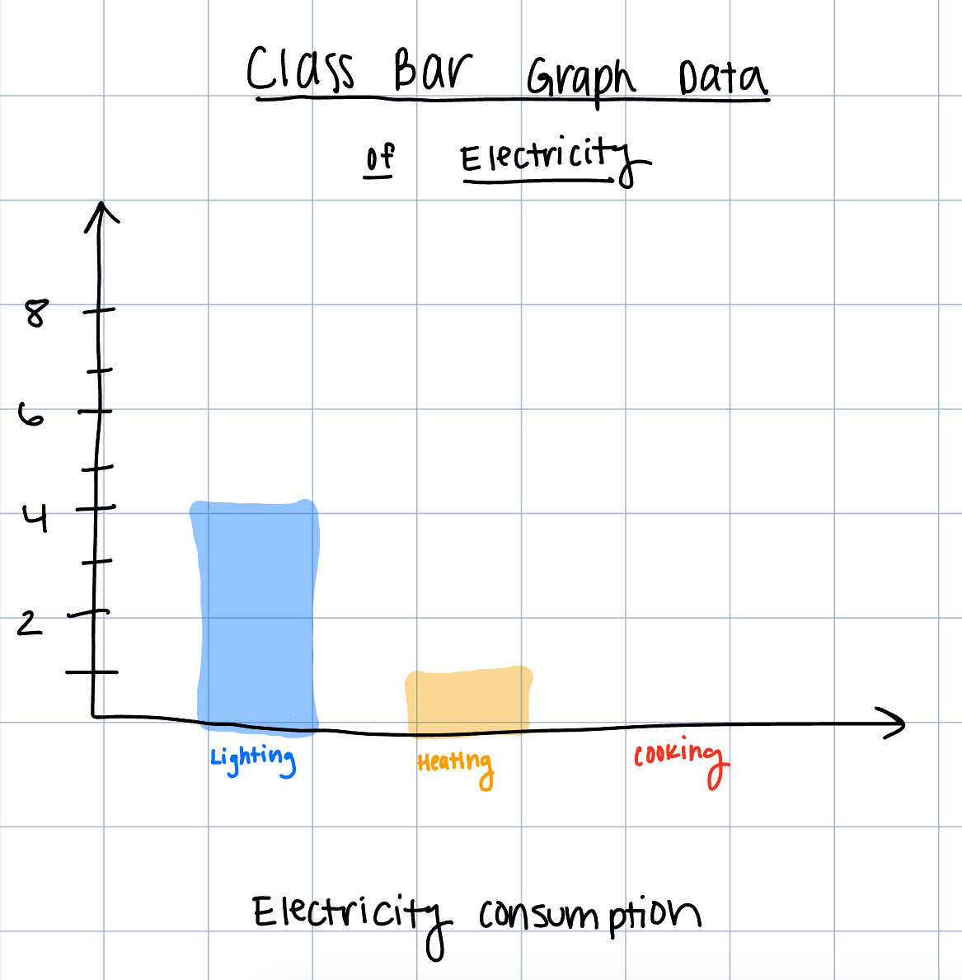  - Students will complete the Graphs and Electricity Use Worksheet in their small groups. These activities will help students understand how to read bar graphs.  - Once the students complete the Graphs and Electricity Use Worksheet, they can add new items to their list, and discuss ways to reduce energy use.
Assessment: | - Glossary entries  - Interpreting graphical data  - Correctly converting between units of energy.

Name: ___________ Date: ____________

Energy Pre-Assessment

Introduction: Brain dump!
- THINK: What do you know about energy and electricity? How do we measure energy? What do we use electricity for in our daily lives?
- Fill in the graphic organizer with:
  - Words,
  - Pictures, and
  - Examples!

Words:

Pictures:

Examples:

Lightbulbs!
Instructions: Read the article from NASA about light bulbs and fill in the following chart. Make sure to include:
- A picture of each light bulb
- Advantages/disadvantages of each lightbulb

Incandescent | CFL | LED

Building Blocks: Test your skills!
- We use energy to turn our light bulbs on.
- If you left a 10 Watt LED lightbulb on for 3 hours, how many kilowatt hours do you use after 3 hours?

- Imagine you had a 60w incandescent lightbulb on for 3 hours, how many kilowatt hours do you use after 3 hours?

- If the cost per kilowatt hour is $0.14, how much money would it cost to keep the lightbulbs on in parts (a) and (b)? How much money would you save if you used a LED light bulb compared to an incandescent lightbulb?

Defining Energy Handout

Instructions: Hope you have the energy to begin our unit on Energy and Electricity! But, what is energy anyway? Today, we will find out.

- Open your math/science notebook to the glossary section.
- Use a textbook or the internet to find definitions for these words:
  - Electricity
  - Energy
  - Power
  - Watt (W)
  - Kilowatt (kW)
  - Kilowatt hour (kWh)
- For each definition, you will:
  - Write the word,
  - Define the word,
  - And draw a picture or write an example to describe each word!

For example:

Word: | Definition: | Picture/Example:
Energy: | The ability to do work. | Solar Energy is a form of energy.  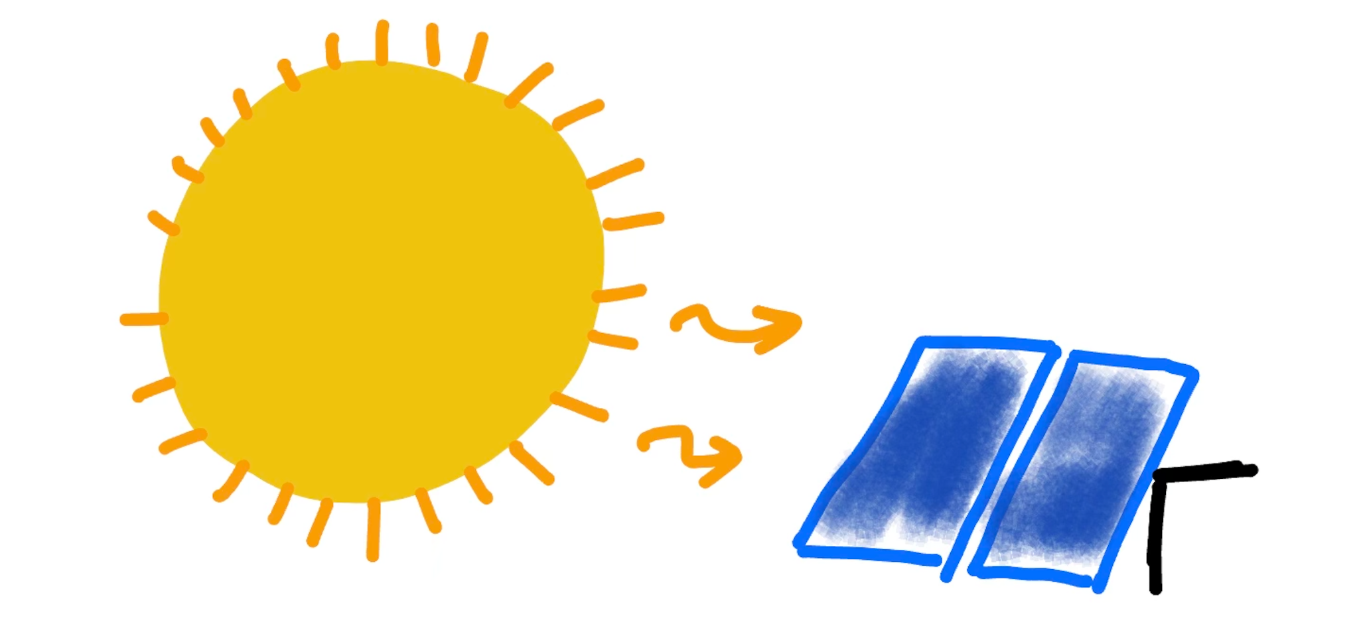

Defining Energy Memory Group Game Handout

Instructions: In your group, cut out these cards. Place them face down. Each member of your group will flip over one card. Each card will either have a definition or a vocabulary word. Then, flip over another card. If the vocabulary word card matches the definition card, remove the card from the game. Then, the next student will pick a pair of cards until all the matching pairs have been found.

Electricity | A form of energy that can be produced in several ways and that provides power to devices that create light, heat, etc.
Watt (W) | A unit of power (J/s).
Energy | The ability to do work.
Kilowatt (kW) | A unit of power equal to 1000W.
Power | The rate of energy use.
Kilowatt hour (kWh) | A measure of electricity defined as a unit of work or energy, measured as 1 kilowatt (1,000watts) of power expended for 1 hour.
Name: ___________ Date: ____________
Energy Unit Conversion

Instructions: Read through all of the problems on the worksheet. Wait for your teacher to explain the Building Block examples. Then, complete the gallery walk. Write the number of the problem in each box for the gallery walk. Remember to include your units.

Remember: We typically use kilowatt hours to describe energy!
P.S. 1000 W=1 kW

Building Blocks:
- Convert 6000 W to kW.

- Convert 5kW to W.

- Recall that Watts and Kilowatts describe power.
  - If you had a 40W light bulb, convert the power of the lightbulb from W to kW.

  - Imagine that you left the light bulb described in part (a) on for 3 hours. How many kWh would you use?

Gallery Walk:
Question #__  Answer:_____________________ | Question #__  Answer:_____________________
Question #__  Answer:_____________________ | Question #__  Answer:_____________________
Question #__  Answer:_____________________ | Question #__  Answer:_____________________

NASA Light Bulbs Article
https://climatekids.nasa.gov/light-bulbs/
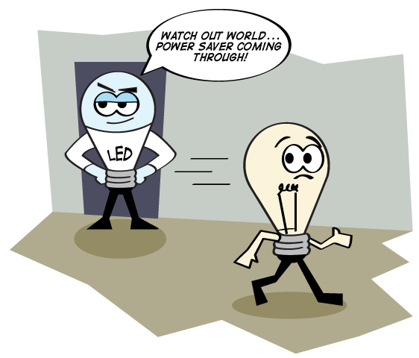
If you need a new light bulb, you have a hard decision to make. There are several kinds of light bulbs to choose from. What are they? Does it make a difference?
Lights use a lot of electricity, so it's important to use the most efficient ones. Efficient bulbs use less electricity to make light. Using less electricity in turn creates less pollution. It's better for everyone.
So what are the different kinds of light bulbs?
The most common light bulbs you can find at the store are incandescent, compact fluorescent (CFL), light emitting diodes (LED), fluorescent, and halogen. It can feel overwhelming!
Let's look at each one individually.

Incandescent
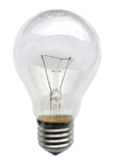
Credit: KMJ, alpha masking by Edokter
If you think about a regular light bulb, you're most likely picturing an incandescent bulb. They have the classic tear-drop shape. You can see the little piece of metal inside the glass that creates the light. This is an old design. These bulbs make a lot of heat when they're turned on. That heat is wasted electricity. For that reason, incandescent bulbs aren't very energy efficient.

CFL
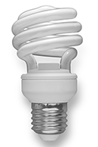
Credit: Sun Ladder
Compact fluorescent bulbs are a newer design. They sometimes are shaped like a coil. These are very energy efficient. They don't create as much heat as incandescent bulbs do. They also last much longer. But CFL bulbs have mercury in them. This is a dangerous element, so CFL bulbs need to be treated with care. You can't throw them in the trash like other bulbs. They need to be recycled. You can take unbroken bulbs to special recycling centers.

Fluorescent
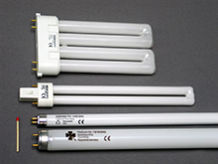
Credit: Christian Taube
Fluorescent lights are the bigger version of CFLs. These are the lights that lots of office buildings and businesses use. They create a lot of light for big areas. Just like CFLs they have mercury in them. They need to be treated with care.

LED
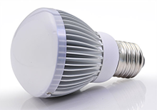
Credit: Led-neolight
Light emitting diodes are another newer design for lighting. They create a lot of light with very little electricity. They're very energy efficient. And they last a very long time - even longer than a CFL. And unlike CFLs, they don't have mercury. That means they're better for the environment. They don't need to be specially recycled. The only problem is that LEDs are much more expensive than other bulbs. But many people would say they are worth it.

Halogen
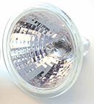
Credit: de:Benutzer:Ralf Pfeifer
Some light sockets use halogen bulbs. These work about the same way as incandescent bulbs. They create a lot of heat, but are a little more efficient than incandescent lights. They last for about one year, and they don't contain mercury. These bulbs are usually used for recessed lights like ones set into the ceiling in homes.

Gallery Walk

Answer: $1.20

Question #1:

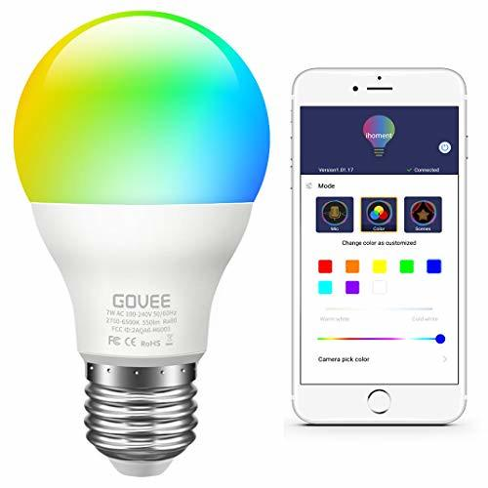

Kate has a 10W LED light bulb in her room. She keeps the light bulb on for 4 hours/day while she does her homework. How many Watt hours (Wh) does she use in 1 day?
Convert your answer into kWh.

Gallery Walk

Answer: 0.04kWh

Question #2:

Carla is making popcorn in a 700W microwave.
Convert the power of the microwave to kW.

Gallery Walk

Answer: 1.2 kW

Question #3:

Jess has a 500W fridge. How many kWh is Jess’ fridge using if it is running for an entire day (24 hours)? Calculate the cost of electricity if the cost per kWh is $0.10.

Gallery Walk

Answer: $0.28

Question #4:

Jace is playing basketball on an outdoor court. Since he has to go to school during the day, he plays basketball at night, so the courts have 10 120W light bulbs. How powerful are the 10 120W light bulbs in kW?

Gallery Walk

Answer: 0.7kW

Question #5:

Russell is watching the Phillies game after school on his 100W TV. Convert the power of the TV from W to kW.
If the game is 3 hours, how many kWh did Russell use while watching the game?

Gallery Walk

Answer: 0.3 kWh

Question #6:

Cristina is baking cookies in her 2000W oven. Convert the power of the oven to kW.
If it takes her 60 minutes to make the cookies and the cost per kWh is $0.14, what is the cost of electricity?

Name: ___________ Date: ____________
Basic Energy Homework

Instructions: Complete the following problems. Make sure to remember your units in your answer.

- Convert 525 W into kW.

- Convert 6.5 kW into W.

- Tyler just bought ice cream and plans to store it in his 300W freezer. Since he cannot finish all of the ice cream in one day, he needs to store the ice cream for 2 days. How powerful is his freezer in kW? How much energy, in kWh, will Tyler use if he keeps his freezer running for 2 days?

- Sarah is listening to her music on her 30W radio for 6 hours. How much energy, in kWh, will she use after the 6 hours?

- Challenge: Lana is using her 900W toaster to heat up her waffles for breakfast. If the waffles take 5 minutes to cook, how much energy is she using, in kWh?

Names: ___________ Date: ___________

How Do We Use Energy at Home?

Instructions: Work with a group to create a list of items that use energy in your home or classroom.

Name: ___________ Date: ___________
Graphs and Electricity Use Worksheet

Instructions: Read the information and look at the graphs. For each of the graphs, describe the trends that you notice. Then, use the information to answer the questions in complete sentences.

Introduction: We use energy and electricity everyday. When we turn on the lights, cook breakfast, and wash clothes, we add to our energy consumption. Every household has different consumption patterns depending on their lifestyle. In this activity, we will explore energy use in our homes.

According to the U.S. Energy Administration Administration, the average American household uses 11,000 kWh per year.
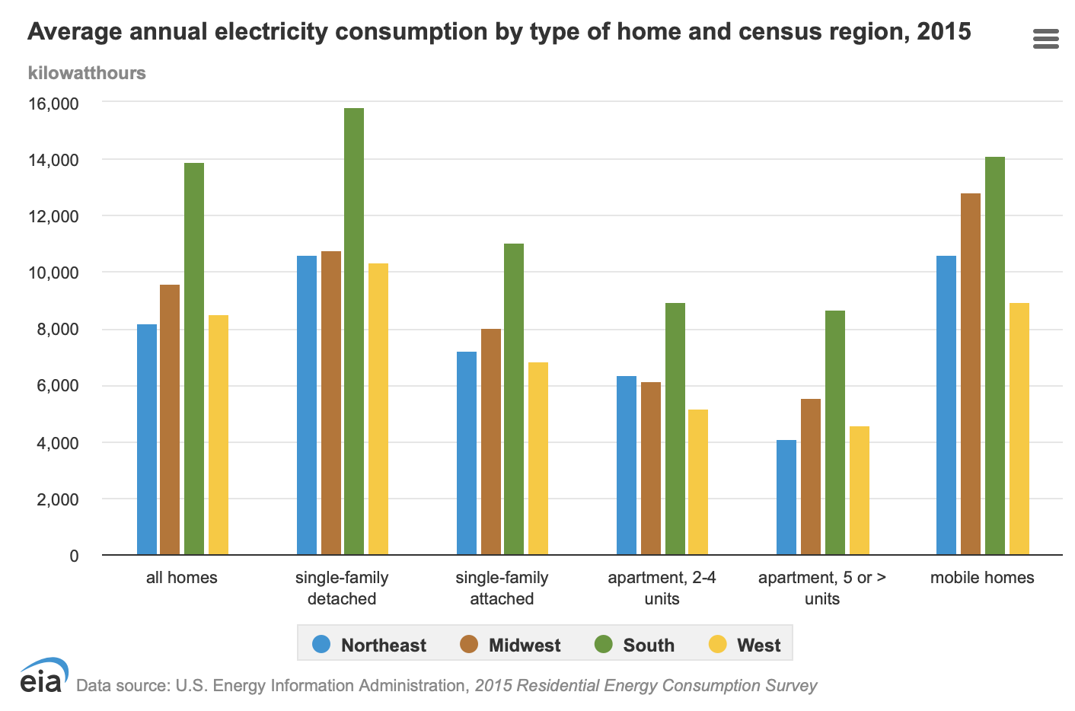
Source: Energy Information Administration
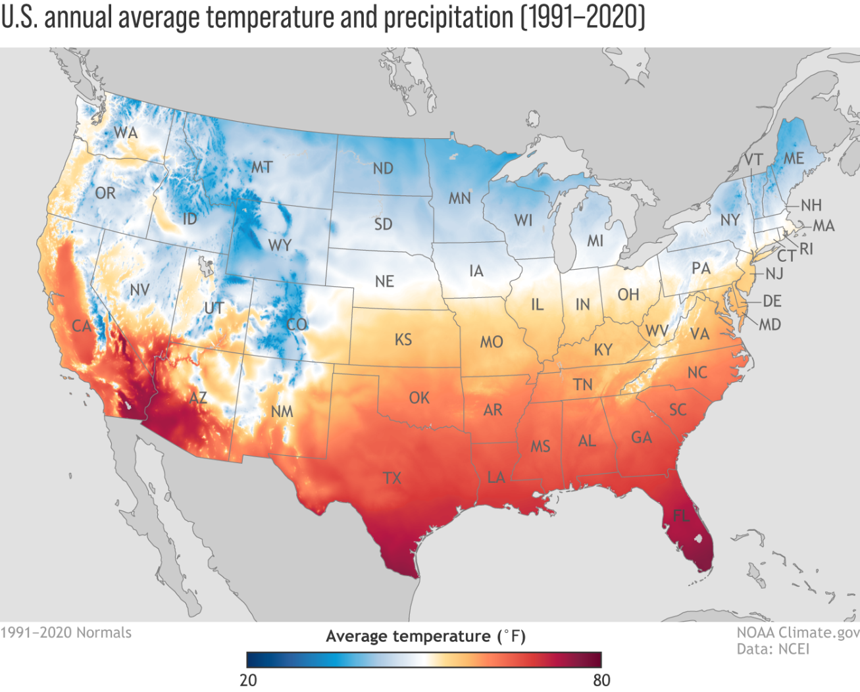
Source: National Oceanic and Atmospheric Administration

THINK: What types of homes have the highest consumption? Which regions of the U.S. have the highest consumption?

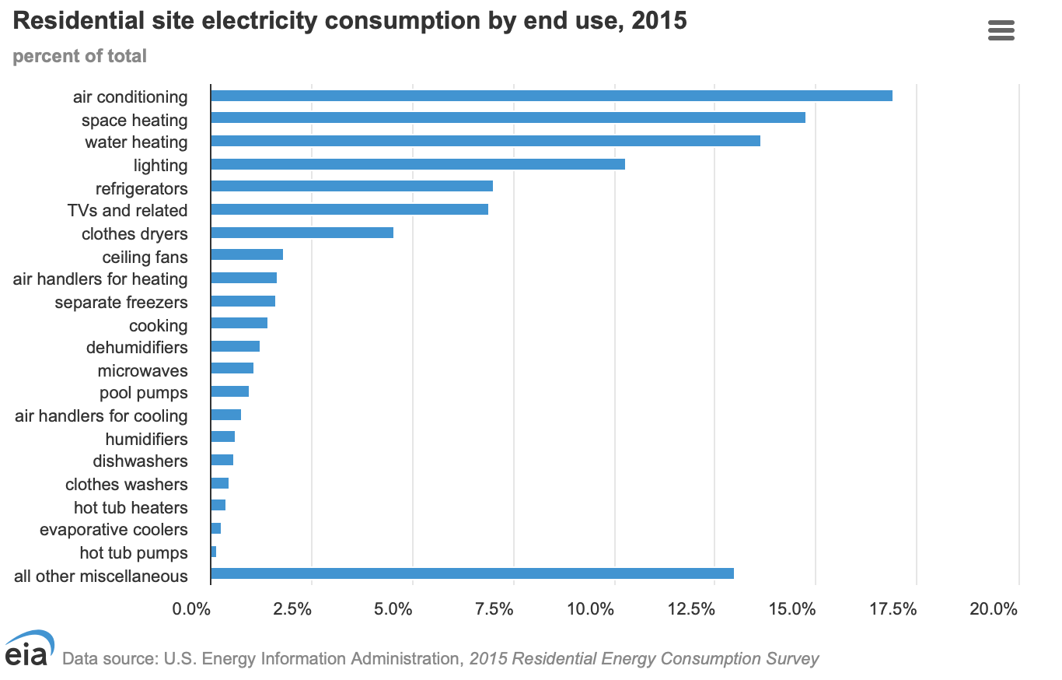Source: Energy Information Administration

Graphs and Electricity Use Recap

Instructions: Using the graphs, answer the following questions in complete sentences.

- Look at the Average Annual Energy Consumption (by type of home and census region).
  - Which region has the highest average annual energy consumption? How many kWh/year does a home (all homes) use in this region?

  - Why does this region have the highest average annual electricity consumption? Use the map to help answer this question.

- Look at the Residential site electricity consumption by end use graph.
  - Which categories use the most electricity? Estimate the percent of the total electricity consumption for the 2 categories that use the most energy.

  - Consider your answer in part 3(a). Why do these categories use the most electricity? Think about electricity use in your home or in the classroom in your explanation.

Cost of Electricity/Energy:

This unit is focused on calculating the cost of electricity and determining ways to save energy in their homes. Students will develop a plan with their parents to audit their homes and use less energy.
This unit is designed to take 2 days. Once the students understand how to calculate energy cost, the second day will be comparing energy usage from the students’ homes and representing the data graphically.

Title: | Cost of Electricity/Energy
Timeframe: | 2 ~45-60 minute sessions (2 days)
Big Ideas and/or Essential Questions | How do we calculate the cost of electricity?  How can we reduce our electric bill and save money?
Vocabulary: | Energy Efficiency  Energy Conservation  Audit  Interquartile range (IQR)  Range  Outliers  Median  Upper and lower quartile  Maximum value  Minimum value  Mean  Mode
PA Standards: | CC.2.1.5.B.2 Extend an understanding of operations with whole numbers to perform operations including decimals.  CC.2.2.5.A.1 Interpret and evaluate numerical expressions using order of operations.  CC.2.4.5.A.2 Represent and interpret data using appropriate scale.
Students will be able to: | - Calculate the cost of energy using multiplication.  - Determine ways to save electricity in their homes.  - Create a plan to reduce energy use.  - Interpret important information from texts.
Materials: | - Electricity Use in Homes Handout  - “How much do lightbulbs cost?” Worksheet  - Electricity Usage at Home Class Graph Template & Worksheet  - PECO Bill  - Calculating Energy Cost Homework Worksheet  - Calculator  - Internet Access  - Monthly Electricity Use Check-in Log (optional)  - Math Notebook
Activity Procedures: | Day 1:  Pre-Activity:  - Before class, write the following questions on the board and facilitate a class discussion regarding the following prompts.  - Why do we turn off the lights whenever we leave the classroom?  - Why do we keep the doors closed while the AC/heating system is running?  - Why do we unplug our electronic devices from the outlets (if applicable)?  Activity 1: Electricity Use in Homes Handout (~10 minutes)  - Students will read the Electricity Use in Homes Handout and highlight vocabulary words used in the reading.  - After reading, students will talk with their table group and give a summary of the content of the handout.  Activity 2 : “How much do lightbulbs cost?” Worksheet (~40 minutes)  - Explain to students that electricity use has a cost and depends on the amount of energy used(on reading).  - Introduce students to calculating cost through basic examples (see below).  - Have students work through the word problems with a partner. The word problems are designed as a “decode the message activity.”  - Once students calculate an answer, the number will correspond to a letter of the alphabet in the key.  - If the students get the answer correct, they should “crack the code” and discover the message.  Day 2:  Activity 3: Electricity Usage at Home Class Graph/Worksheet (~30-45 minutes)  - Have students turn in Calculating Energy Cost Homework.  - As students enter class, have them report the average kWh used per month for their last electricity bill (could be a way of taking attendance). This should be on the Calculating Energy Cost Homework.  - Create a boxplot using the reported kWh used for the month using class data. See attached box plot generator here.  - Explain to students why we use a boxplot to represent the data points. Use the board to write down the following information for students to write in their worksheet.  - Explain what a boxplot is: a box plot is a graph that displays the distribution of data. Show students how to read a box plot.  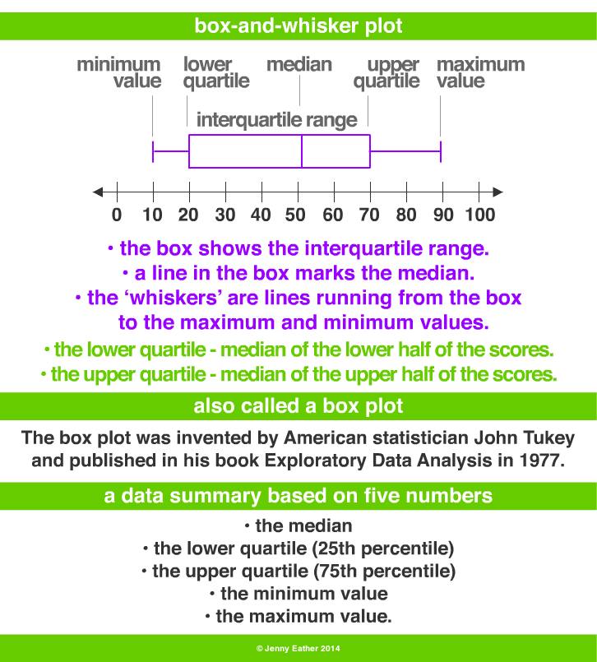  - Box plots tell us:  - Median: value in the middle of data set  - Upper quartile: median of the upper half of the data  - Lower quartile: median of the lower half of the data  - Maximum value  - Maximum value  - From boxplots, we can determine the range: the difference between the maximum and minimum value.  - Define these words for students  - Interquartile range (IQR): Difference between Q1 and Q3  - Outliers: a data point that is significantly different from the rest of the data points. Calculating outliers is likely beyond the 5th grade curriculum, but the formula is:  - Find Q3 + (1.5 * IQR)  - Find Q1 – (1.5 * IQR)  - All data outside these data points are outliers.  - Have students fill in their notes about boxplots on the Electricity Usage at Home Class Worksheet. Define all centers of measure:  - Mean: arithmetic average, add up all the data points and divide by the number of data points  - Mode: data point that appears the most  - Ask students: Why might there be an advantage to using the median or mode? Think about outliers. This should be a class discussion.  - Show students the class boxplot data for the average kWh used per month for their last electricity bill. Have students fill in the worksheet and write in the median, upper and lower quartile, range, IQR, maximum value, and minimum value.  - Have students complete the rest of the worksheet about calculating mean, median, and mode.
Homework: | The homework is designed to be completed before Day 2. Students will complete Calculating Energy Cost Homework Worksheet and discuss ways to save money by reducing energy use in their homes with their parents. Students will turn in a PECO bill with the worksheet. Students will create a plan to decrease energy use.
Extension | Activity #5 (optional): Monthly Electricity Use Check-Ins  - Every month, students will complete the Monthly Energy Use Check-In Log.  - Have students record their monthly energy use in their homes. Note: Energy use fluctuates from month to month due to changing weather conditions. Ask students how the seasons may affect electricity use in their homes.  - Have students explain why their energy use increased/decreased from month to month.  - After reviewing the trends, have students audit their energy use in their home and write down ways to decrease energy use.
Assessment: | - Summarize and identify main ideas from text.  - Interpret data from graphs.  - Compute cost of electricity usage.

Name: ___________ Date: ___________
Electricity Use in Homes Handout

Instructions: Read the following information about Electricity Use in Homes. Highlight vocabulary words and underline important information in the text. For each graph, write 1 observation about the data presented. Every 1-2 paragraphs, write one sentence summarizing what you read. At the end of the reading write 2-3 sentences summarizing the entire handout.

Imagine your life without electricity. Would you still be able to read this handout? Would you still be able to cook breakfast? Would you be able to see without the lights turned on? Clearly, our life would be different without electricity. Unfortunately, electricity use has a cost, both financially and environmentally, so we must consider the effects of our electricity consumption.

Source: Energy Information Administration

Every household has different electricity consumption patterns, but in general, air conditioning, space heating, and water heating are the top consumers of electricity in a residential site.

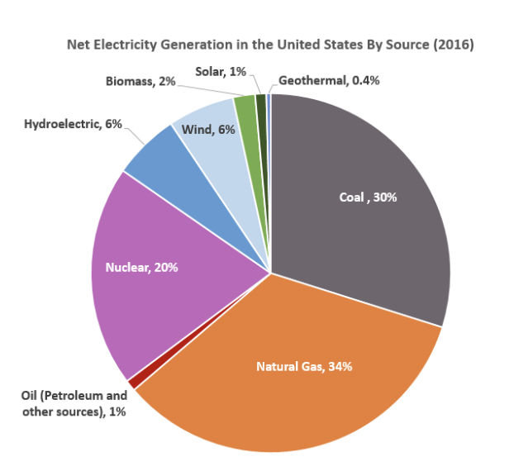
As mentioned earlier, there is an environmental cost to high electricity consumption. Electricity is primarily generated by non-renewable fossil fuels, such as coal, oil, and natural gas, which release greenhouse gasses into the atmosphere. Greenhouse gasses absorb and trap heat in the atmosphere and contribute to global warming.

Source: U.S. Energy Information Administration, Electricity Data Browser. These data were accessed in December 2017.

There is also a financial cost to using electricity. Electricity cost is calculated by adding the service fee, a fixed cost for the electricity equipment, and the cost per kilowatt hour (kWh). In Pennsylvania, the cost per kWh is about 14 cents.

For environmental and financial reasons, it is important to consider ways to conserve energy or be more energy efficient.

Energy conservation involves implementing actions to lessen our energy use. For example, when we leave a room, we can turn the lights off to save electricity and use natural lighting when it is sunny outside.

Energy efficiency typically involves using appliances that use less energy than the traditional alternative. For example, certain light bulbs, such as LED light bulbs, use less electricity than older lightbulb models, such as the incandescent light bulb.

Think about electricity use in your home or classroom. Have you ever implemented methods to conserve energy or be more energy efficient?

Summary:

Name: ___________ Date: ___________
How Much Do Light Bulbs Cost? Worksheet

Instructions: Read through all of the problems on the worksheet. Wait for your teacher to explain the Building Block examples. Next, work through the decoding word puzzle with a partner. Remember to include your units.

Fun fact: The average electricity cost in Pennsylvania is ~ $0.14/kWh!

Building Blocks:

- Suppose you have a 60W light bulb.
  - Convert the power of the light bulb to kW.

  - If the light was on for 3 hours/day, how much would it cost to keep the light bulb on for that day?

  - How much would it cost to keep that light bulb on for a week, if you continue to keep it on for 3 hours/day?

- Your electric bill is now too high, so you decide to conserve energy by keeping your 60W light bulb on for 1 hour/day.
  - If the light was on for 1 hour/day, how much would it cost to keep the light bulb on for that day?

  - Compare this answer to 1(b). How much money do you save when you keep your light bulb on for 1 hour/day?

Instructions: Next, complete the word puzzle with a partner. Solve each problem and find the corresponding answer in the key below to decode the answer. Assume that electricity cost is $0.14/kWh. Remember to include your units.
Question: Why did the electrician eat a lightbulb?
They wanted a _ _ _ _ _ snack!
1 2 3 4 5

- Crystal buys 2 80W light bulbs for $2 each. Calculate the power of 1 lightbulb in kW.

- If Crystal uses both lightbulbs from (1) for 4 hours/day. How many kWh does she use in one day?

- Use your answer from (2) to calculate the operating cost of the lightbulbs for one day. Round your answer to the hundredths place.

- Crystal is trying to save money. She wants to know how much money she is spending to pay for the lightbulbs (initial cost) and the operating cost. How much money has Crystal spent on the lightbulbs after 1 day? Round your answer to the hundredths place.

- Crystal wants to implement ways to conserve energy. Now she only uses 1 80W light bulb for 1 hour/day. Calculate the operating cost of the lightbulb for one day. Compare that number to the number you calculated in (3). How much money is Crystal saving? Round to the hundredths place.

A= 2.80
B= 2.40
C= 4.00
D= 7.17
I= 0.64
J= 9.90
K= 2.34
L= 0.08
Q= 8.91
R= 0.64
S=0.76
T= 0.08
Y= 10.00
Z=100.00
E= 6.50
F=0.50
G= 0.09
H= 4.09
M= 6.78
N= 2.00
O= 11.10
P= 5.00
U= 0.00
V= 7.90
W= 12.30
X= 6.00
KEY:
Name: ___________ Date: ___________
Calculating Energy Cost Homework
Instructions: This assignment focuses on calculating energy cost in your home. Ask your parent/guardian for a copy of their most recent electric (PECO) bill. Use the PECO bill to answer the following questions. Staple your PECO bill to the back of this worksheet. For more help understanding your bill, use this video from PECO: https://www.youtube.com/watch?v=5ihrs3QL1Ps
Remember to include your units.

- An electric meter measures the amount of electricity you use in your home. Look for the Meter Information section. In this section, you will find the previous meter reading and the present meter reading.
  - Calculate the difference of the previous meter reading and the present meter reading to get the total kWh of electricity used during the month. Compare your calculation to the total kWh of electricity that is stated on the bill. Hint: they should be the same!

  - Watch this video to help you understand how to read your electric meter: ​​https://www.youtube.com/watch?v=b-1hJKHmkWA. Ask your parent/guardian where your electric meter is located. Do you have a digital meter or a dial reader?

  - Read your electric meter and report the current total usage in kWh.

- Find your usage profile. You should see a graph of your monthly electricity use for the year, along with your usage for the month.
  - What is your average daily usage for the month, in kWh?

  - Is your average daily usage for the month higher or lower than last year?

  - What is your average kWh used per month?

  - Look at the graph of annual monthly electricity use. Which months have the highest consumption? Which months have the lowest consumption? Explain why you may use more electricity during these months using complete sentences.

- Have your parents register or log into their MyPECO account with this link: (https://www.peco.com/WaysToSave/ForYourHome/Pages/MyOnlineAccountTools.aspx). The MyPECO account allows homeowners to compare their home energy usage to their neighbors with similar sized homes.
- Use your MyPECO account to access your home energy report. Compare your household energy consumption to your neighbors. How does your family’s energy use compare to your neighbors? Is your energy usage average? Above -average? Below average?

- Interview your parent/guardian. Have they ever tried to save energy in their homes? If so, write down 3 ways that they have tried to reduce their energy use.

- Visit the PECO website: https://www.peco.com/WaysToSave/ForYourHome/Pages/YearRoundSavingsTips.aspx. What are additional ways to save energy in your home? Write and implement at least 2 of the tips listed on the PECO website.

Name: ___________ Date: ___________
Electricity Usage at Home Class Worksheet
Instructions: Fill in the graphic organizer with information from your teacher’s lesson on boxplots.

What is a box plot?

What does a box plot look like? How do we draw one?

What do box plots tell us?

Definitions:
- Median:
- Upper quartile:
- Lower quartile:
- Maximum value:
- Minimum value:
- Interquartile range (IQR):
- Range:
- Outliers:
- Mean:
- Mode:

Instructions: Your teacher will make a box plot of the class’ average kWh used per month. Report the following data points and remember your units:

- Median:

- Upper quartile:

- Lower quartile:

- Maximum value:

- Maximum value:

- Interquartile range (IQR):

- Range:

- Now, draw the box plot and label it using the data points you listed above. Include a title and a scale at the bottom!

Instructions: Look at the following data.

- Determine the mean, median, and mode for the sample. You may use a calculator.

Average kWh Used per Month
1,000
1,000
800
900
950
1,000
750
800

Name: ___________ Date: ___________
Monthly Electricity Use Check-in Log

Instructions: At the end of every monthly billing cycle, complete the Check-In Log and answer the following prompts in complete sentences:
- How many kWh did you use last month?
- Look at your previous entries (if applicable), did you use more or less electricity than before? Provide an explanation.
- Write at least 1 thing you can do to reduce electricity in your home.

Month: | Log:

Solar Energy:

This unit is focused on solar energy. This lesson plan is designed for 2 days. Students will watch a video to review the basics of solar energy and then work to calculate the area of rectangles to understand the necessity for space when installing solar panels. Students will complete the Solar Energy Interview Worksheet at home.
Students will then work to calculate residential solar energy production in Philadelphia and determine if solar energy production can offset the average household consumption. Students will discuss ways to decrease energy consumption.

Title: | Solar Energy
Timeframe: | 2 ~4-60 minute sessions (2 days)
Big Ideas and/or Essential Questions | How do solar panels convert sunlight into energy?  How do we determine if there is adequate space for solar panels?  How can we determine and calculate solar production?  How does solar energy production compare to the current consumption of fossil fuels?
Vocabulary: | Solar Energy  Solar Panel  Non-Renewable Energy  Renewable Energy  Fossil Fuels
PA Standards: | CC.2.1.5.B.2 Extend an understanding of operations with whole numbers to perform operations including decimals.  CC.2.1.5.C.2 Apply and extend previous understandings of multiplication and division to multiply and divide fractions.  CC.2.2.5.A.1 Interpret and evaluate numerical expressions using order of operations.  CC.2.4.5.A.1 Solve problems using conversions within a given measurement system.  CC.2.4.5.A.2 Represent and interpret data using appropriate scale.  CC.2.4.5.A.5 Apply concepts of volume to solve problems and relate volume to multiplication and to addition.
Students will be able to: | - Calculate solar production based on provided data from residential solar panel systems.  - Calculate area of rectangles.  - Determine whether solar energy production can offset the average PECO customer usage.  - Understand the benefits of using renewable energy, specifically solar energy, instead of traditional fossil fuels.  - Summarize and identify important information from videos.
Materials: | - Internet Access  - Solar Energy Entrance Ticket  - How does Solar Energy Work? Video Guide  - Is there space? Activity (Handout and Worksheet)  - Scissors  - Solar Energy Interview Worksheet (HW)  - Calculating Solar Production Worksheet  - PECO Bill  - Solar Production Homework  - Internet Access  - Board Game Template and Handout (optional)  - Dice (optional)
Activity Procedures: | Day 1:  Activity #1: Solar Energy Entrance Ticket (Pre-Assessment, ~5-10 minutes)  - Have students complete the Solar Energy Entrance Ticket as they enter class.  - Have students discuss the Solar Energy Entrance Ticket with a partner (Think-Pair-Share).  Activity #2: Solar Energy Basics (~15 minutes)  - Have students watch the following video: https://www.youtube.com/watch?v=m74bMrxhBkw  - Students will complete How does Solar Energy Work? Video Guide while they watch the video. This should be a review from the PSEA Science Curriculum and Lesson on Solar Energy. Teachers may choose to spend more time here if the students need to review that lesson.  - After watching the video, ask students if they know what type of energy is used to power their homes. Do any students have solar panels at home? Do any students use renewable energy sources to power their homes?  - Optional-facilitate a discussion on the pros/cons of Solar Energy by creating a T-Chart.  Activity #3: Is there space? Activity (~20-25 minutes)  - Have students follow instructions on the Is There Space? Handout.  - Students will be given a grid to represent a given amount of space, say a house and backyard.  - The activity materials will contain rectangular paper of different sizes. These pieces will represent the size of the house or solar panel.  - Depending on the size of the solar panels, students will follow the handout instructions to calculate the area of the “solar panels” and the amount of “space” (area) on the corresponding worksheet.  - Once students complete the activity, they will answer the application question on the worksheet to calculate the area of a real residential solar panel.  Day 2:  Activity #4: Class Discussion (~5-10 minutes)  - Ask students about their discussion about solar energy with their parents. This could also be done in a small group/table setting.  - If necessary, review definitions for watts, kilowatts, and kilowatt hours.  Activity #5: Calculating Solar Production Worksheet (~45-50 minutes)  - Guide students through the front of the Solar Production worksheet.  - The following website:https://pvwatts.nrel.gov/pvwatts.php, calculates average solar radiation based on location. For the purposes of standardizing the lesson plans, the location is based on Philadelphia City Hall.  - Once students review calculating energy, guide them in calculating solar production (on the worksheet).  - From the NREL database, solar panels produce ~4.75kWh/m²/day.  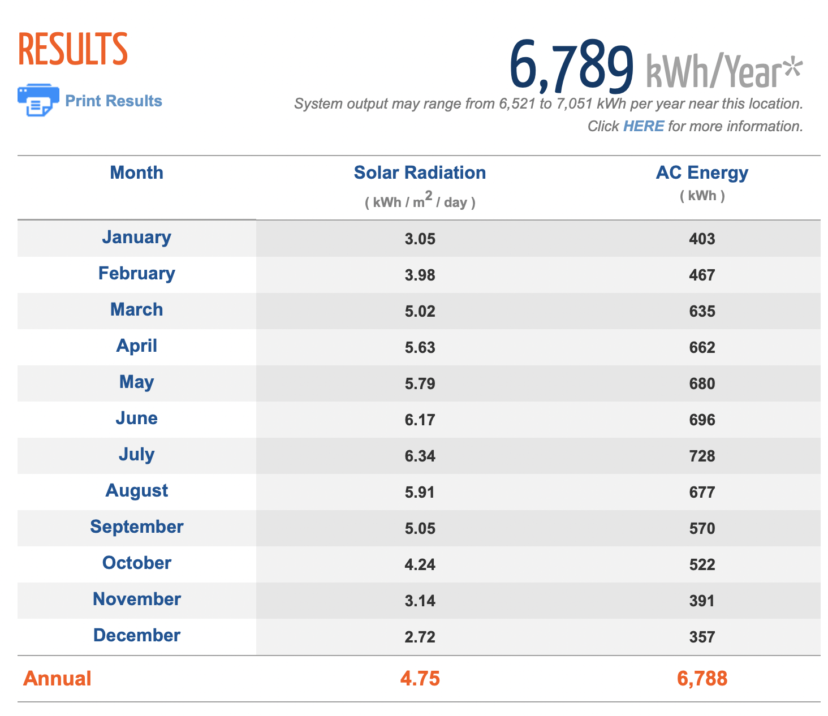  - Note that the average size of a residential PV system in the U.S. is 5 kW, so in Philadelphia, solar production is roughly 6,800 kWh/year.  - Have students calculate the kWh/month. To guide students, ask them how many months are in a year. For reference 6,800 kWh/12 months=~566 kWh/month.  - Have students compare this 566 kWh/month to their own usage per month (on the students PECO bill). Note that the average American household uses 886 kWh/month. Calculate the difference between the solar production and energy usage. What does this tell us about our energy use? How can we decrease this difference?  - Have students begin the Solar Production Homework if there is time left in class.
Homework: | After Day 1, students will complete the Solar Energy Interview Worksheet with their parents/guardians. The worksheet will focus on calculating area in relation to solar panels and initiate a discussion on solar energy with their parents.  After Day 2, students will complete Solar Production Homework. This worksheet will focus on word problems based on the calculations covered in class.
Extension | Activity 6 (optional): DIY Solar Energy “Candyland” Board Game (~90 minutes). See: http://www.greeneducationfoundation.org/institute/lesson-clearinghouse/362-make_energy_board_games.html  - Have students use the Board Game Template to create their own board game with their groups. See:http://www.greeneducationfoundation.org/institute/lesson-clearinghouse/362-make_energy_board_games.html  - Each group is tasked with the following:  - Prompt: Each player represents a household. Each household is trying to cut down electricity. The students will be provided a pair of dice to determine each move.  - Students must incorporate the following:  - 2 math problems that involve:  - Unit conversion between Watts, Kilowatts, Kilowatt Hours  - Calculating the cost of energy based on kWh.  - 4 Forward/backward progression prompts (2 each)  - Forward prompts (advancing places) can be:  - Installing solar energy panels  - Turning off lights  - Backwards prompts (skip turn/go back) can be:  - Wasting water  - Leaving AC on at all times  - Keeping devices plugged in  - Students can play each others’ games once they finish.
Assessment: | - Calculating solar production  - Calculating area

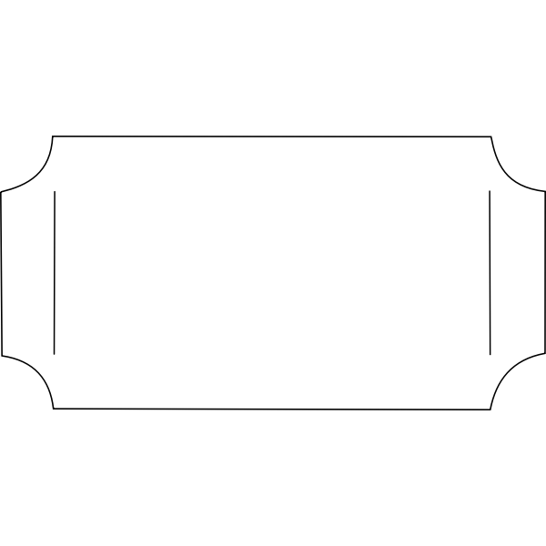
Name: ___________ Date: ___________
Solar Energy Entrance Ticket
Instructions: Answer the following questions in complete sentences. Then, share you answers with a partner.
Have you ever seen solar panels before? If so, where?

How do solar panels get their energy?

Is solar energy a renewable or non-renewable source of energy?

Write at least 1 question that you have about solar energy.
Name: ___________ Date: ___________
Solar Energy Entrance Ticket
Instructions: Answer the following questions in complete sentences. Then, share you answers with a partner.
Have you ever seen solar panels before? If so, where?

How do solar panels get their energy?

Is solar energy a renewable or non-renewable source of energy?

Write at least 1 question that you have about solar energy.

Name: ___________ Date: ___________
How does Solar Energy Work? Video Guide
Instructions: Watch the following video in-class and answer the questions below in complete sentences.

- How can we “harness the power of the sun”?

- What type of cells make up solar panels? What are these cells made of?

- Fill in the blank: Concentrated solar panels (CSP) systems use __________ to direct sunlight onto a small target to eventually generate electricity.

- List advantages of solar energy.

- List disadvantages of solar energy.

Is there space? Activity Handout
Instructions: Imagine you want to install solar panels in your home. In order to install solar panels, you must take into consideration multiple factors, such as cost or space. This activity focuses on the spatial considerations that you must make when deciding to install solar panels in your home.

- Cut out all of the pieces on the next page. Note that each square represents 1 square foot. Notice that this represents the area. (THINK: How do I calculate the area of a square?). For this exercise, assume you cannot place solar panels on roofs and you can only place them on the ground (free space).

- Answer questions 1-3 on the worksheet.

- Place as many solar panels as possible on your house property grid. Answer question 4.

This is your property: See the key below for more information.

 |  |  |  | ____ | ____ | ____ | ____ | ____ | ____
 |  |  |  |  |  |  |  |  | |
 |  |  |  |  |  |  |  |  | |
 |  |  |  |  |  |  |  |  | |
 |  |  |  |  |  |  |  |  | |
 |  |  |  |  |  |  |  |  | |
 |  |  |  |  |  |  |  |  | |
 |  |  |  |  |  |  |  |  | |
 |  |  |  |  |  |  |  |  | |
 |  |  |  | ____ | ____ | ____ | ____ | ____ | ____

Key:

Color | Representation
 | Free Space- You can build solar panels here!
 | Sidewalk
 | Garden
 | House
 | Pool
______________ | Fence

Is there space? Activity Cut Outs

Instructions: Cut out these “solar panels”.

Name: ___________ Date: ___________
Is there space? Activity Worksheet
Instructions: Follow the instructions on the handout to complete the activity and answer the questions. Remember your units.

- BRAINSTORM: If you wanted to install solar panels, what factors would you have to consider?

- Each square represents 1 square foot. If you can only place solar panels on the free spaces, how much available square feet do you have to install solar panels? Remember that the area of a square is: (length of side)*(length of side)= area of a square.

- Calculate the area of each “solar panel.”

- How many solar panels could fit on the property grid?

- Calculate the total area of solar panels that fit on the property.

- In real-life, solar panels are typically shaped as rectangles, not squares. Recall the formula for the area of a rectangle. Imagine that you are installing a solar panel that has a length of 3.5 feet and a width of 5 feet. What is the area of this solar panel?

Name: ___________ Date: ___________
Solar Energy Interview Worksheet- Homework
Instructions: With the help of your parent/guardian, answer the following questions in a paragraph format.
- What are the energy sources we use to power our home and why? Are they renewable or nonrenewable?
- What are the advantages and disadvantages of using the energy source that we are currently using?
- Have you ever considered using renewable energy sources, specifically solar energy? Why or why not?

Part 2: Answer the following question. Make sure to remember your units.

- Eliza wants to install solar panels on her roof. She wants to determine how much space the solar panels take up. Suppose she wants to install 2 dollar panels. One of the solar panels is 4 ft in length and 4.5 ft in width. The other solar panel is 6 ft in length and 2.5 ft in width. What is the combined area of both solar panels?

- Eliza’s friend, Hannah, also wants to install solar panels. She asks Eliza for advice. Eliza tells her to measure the area available for solar panels on the roof. Hannah determines that she has 14 square feet available for solar panels. If Hannah buys a solar panel that is 3 ft in length and 5.5 ft in width, will this solar panel fit on her roof?

Name: ___________ Date: ___________
Calculating Solar Production Worksheet
Instructions: Answer the following questions. Your teacher will guide you through this worksheet. Remember your units.

To calculate solar production (kWh), you need:
- Average hours of sun in the region
- Power rating (in KW)
- This is calculated by: Array Area (m²) × 1 kW/m² × Module Efficiency (%)
  - For our purposes, we will assume that the module efficiency is about ~20%.
Note: Solar production depends on a variety of factors, including tilt, array type, and inverter efficiency. For simplicity, we will only consider average hours of sun per day and power rating.

Look at the map below. Think about which regions would be the best for solar energy.
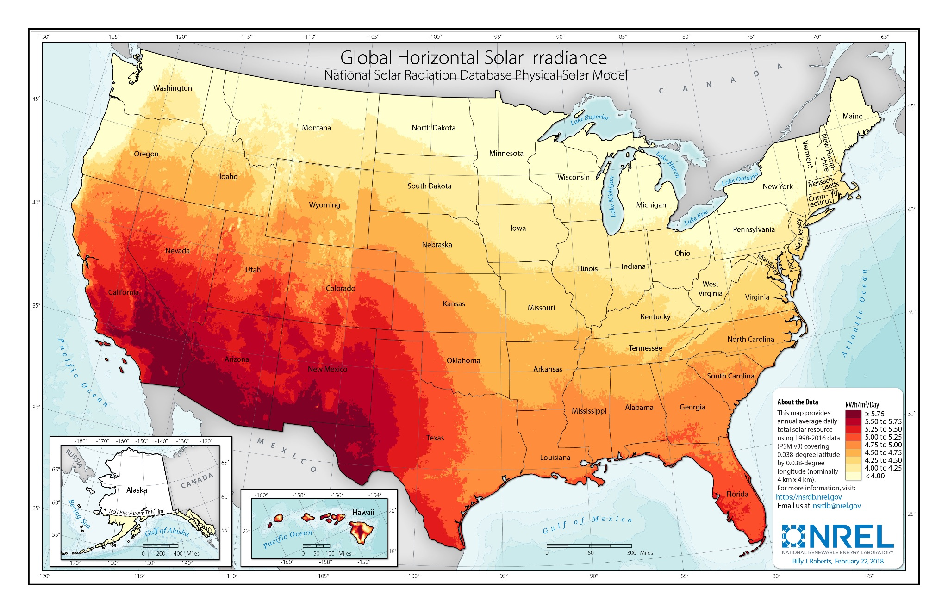 Source: National Renewable Energy Laboratory (NREL)

Examples:
- Austin buys a solar panel. The array area is 5 m². Austin lives in Austin Texas, where he receives about 5.5 hours of sunlight per day. Calculate the solar production.

- Austin’s friend, Carlos, has solar panels. The array area is 10 m². Carlos lives in Philadelphia, Pennsylvania where he receives about 4.6 hours of sunlight per day. Calculate the solar production.

Source: National Renewable Energy Laboratory
The average size of a residential solar system in the U.S. is 5kW. The chart above estimates the solar production of a 5kW system in Philadelphia.

- Using the chart, about how many kWh will the solar system produce in a year. For simplicity, round the answer to the hundreds place.

- Using your answer in (1), calculate the kWh/month. Remember that there are 12 months in 1 year.

- The average American household uses about 886 kWh of electricity per month. Compare this consumption to solar production. Can solar production offset the consumption of an average American household? Calculate the difference between solar production and consumption of an average American household.

- Bonus challenge! Use your PECO bill from the previous lesson and find the amount of kWh of electricity your household used. Can solar production offset your electricity consumption?

Name: ___________ Date: ___________
Solar Production Homework
Instructions: Answer the following questions. Remember your units.
To calculate solar production (kWh), you need:
- Average hours of sun in the region
- Power rating (in KW)
- This is calculated by: Array Area (m²) × 1 kW/m² × Module Efficiency (%)
  - For our purposes, we will assume that the module efficiency is about ~20%.
Note that these are simplified calculations.

- Camryn wants to buy solar panels to reduce her usage of fossil fuels. The array area is 7 m². Camryn lives in Philadelphia, Pennsylvania where she receives about 4.6 hours of sunlight per day. Calculate the solar production.

- After learning about solar energy in school, Jayden talks to his parents about installing solar panels in his home. Jayden lives in Philadelphia, Pennsylvania where he receives about 4.6 hours of sunlight per day.
  - The array area of the solar panels he wants to buy is 7 m². Calculate the solar production.

  - Jayden’s family uses 1,000 kWh of electricity per month. Is the solar production enough to offset his family’s electricity use? Calculate the difference.

  - Jayden’s neighbor, Nathan, also wants to install solar panels. He wants to buy solar panels with an array area of 10 m². His family is very energy conscious and uses about 500 kWh of electricity per month. Is the solar production enough to offset his family’s electricity use? Calculate the difference.

DIY Solar Energy Board Game Handout
Instructions:
- Work in groups to use the board game template to make a board game about solar energy.
- The game is similar to “Candyland”, where each player rolls dice to determine their movement on the board.
- Design 4-6 pawns for the game. Each pawn represents a household.
- The prompt or goal of the game is to reduce energy use.
- In your game, you must include:
- 2 math problems that involve:
  - Unit conversion between Watts, Kilowatts, Kilowatt Hours
  - Calculating the cost of energy based on kWh/array size/sunlight.
  - Make a key for answers
- 4 Forward/backward progression prompts (2 each)
  - Forward prompts (advancing places) can be:
      - Installing solar energy panels
      - Turning off lights
- Backwards prompts (skip turn/go back) can be:
      - Solar panels breaking
      - Solar panels become too expensive
- Use your creativity to fill in the rest of the board with drawings or more prompts about solar energy.
See Mini-Example:
 | Convert 1000W into kWh. If you get the answer correct: move forward 1 space. If you get the incorrect answer, move back 3 spaces
 |  |  | You installed 2 solar panels. Move forward 2 spaces.
END:

START: | You left your lights on all day. Move back 1 space.
Names: ______________ Date: ___________
DIY Solar Energy Board Game

FINISH:

START:

Resources:
https://www.eia.gov/energyexplained/use-of-energy/electricity-use-in-homes.php
https://www.youtube.com/watch?v=m74bMrxhBkw
https://pvwatts.nrel.gov/pvwatts.php
https://www.seia.org/research-resources/solar-photovoltaic-technology
https://www.eia.gov/tools/faqs/faq.php?id=97&t=3
http://www.greeneducationfoundation.org/institute/lesson-clearinghouse/362-make_energy_board_games.html
https://www.climate.gov/news-features/featured-images/new-maps-annual-average-temperature-and-precipitation-us-climate
https://www.eia.gov/kids/glossary.php
https://www.epa.gov/energy/about-us-electricity-system-and-its-impact-environment
http://www.eia.gov/electricity/data/browser/
https://www.electricchoice.com/electricity-prices-by-state/
​​https://www.youtube.com/watch?v=b-1hJKHmkWA
https://www.youtube.com/watch?v=5ihrs3QL1Ps
https://www.nrel.gov/gis/solar-resource-maps.html
https://www.peco.com/WaysToSave/ForYourHome/Pages/MyOnlineAccountTools.aspx
https://www.peco.com/WaysToSave/ForYourHome/Pages/YearRoundSavingsTips.aspx
http://www.amathsdictionaryforkids.com/qr/b/boxandwhiskersplot.html
https://www.desmos.com/calculator/h9icuu58wn
https://css.umich.edu/publications/factsheets/energy/photovoltaic-energy-factsheet
https://www.turbinegenerator.org/solar/texas/austin/
https://www.turbinegenerator.org/solar/pennsylvania/philadelphia/
https://dictionary.cambridge.org/us/dictionary/english/electricity
https://climatekids.nasa.gov/light-bulbs/

